Movie Trailer Pitch Assignment
With your group you will be assigned a movie title. The project is marked out of 50. Together as a group you must:
- Decide the genre of the movie. Explain what 3 elements of your film will relate to this genre
- Cast the movie (Minimum of 3 actors, defend your choices.
- Determine the Monomyth story arc of the film
- Identify the audience/demographic/psychographic and explain how your movie will appeal to this target audience.
- What 2 products could you ‘tie in’ to the launch of the film and explain why these products would appeal to your target audience?
- Determine the moral or message of the story.
- Written Response for each group member detailing their role in the creation of the trailer.
- Create a storyboard (10-20 images) for a 30 second commercial trailer. You may wish to film it, but that isn’t necessary for this mark.

Use stick figures or collage to create a 6-12 panels. Use a page for each panel.
You will present your storyboard as a trailer. Bring in music or sound effects if you like. Presentation day will be: ____________________
You will then hand in your project as a group.

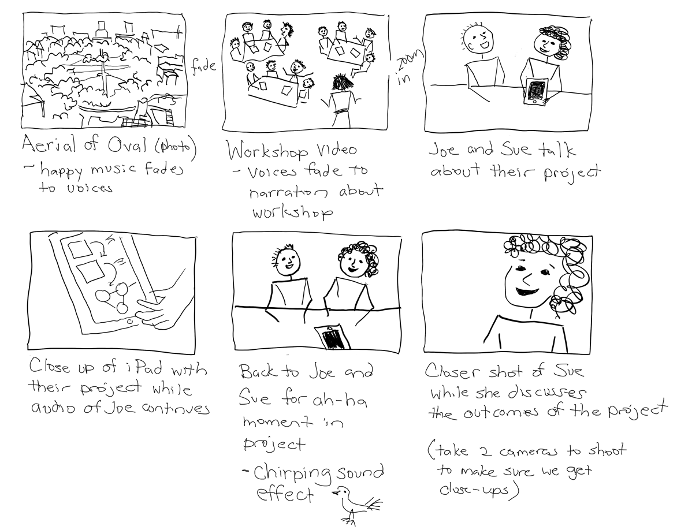

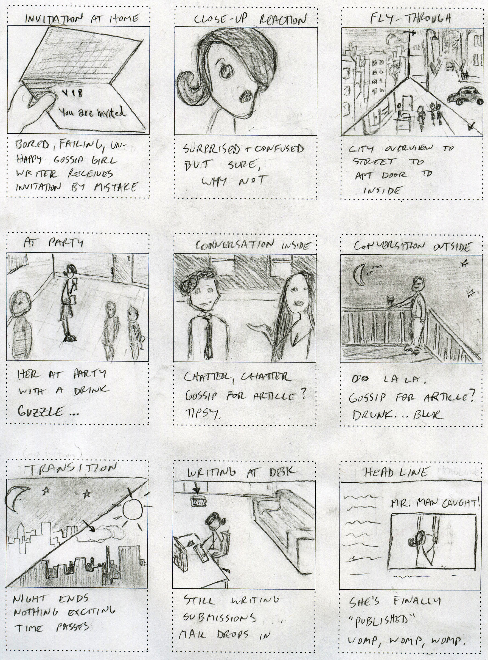
Use one page of 8.5 x 11 turned sideways paper for each storyboard panel.
You will need 6-12 pages for a standard 30 second trailer.

Film Trailer Presentation Rubric

Students:

Criteria | Level 1 | Level 2 | Level 3 | Level 4 | Mark
Knowledge/  Understanding  -information, ideas and concepts | Shows limited understanding of trailer elements | Shows some understanding of trailer elements | Shows considerable understanding of trailer elements | Shows thorough understanding of trailer elements | /5
Thinking/Inquiry  -analysis | Uses limited logical analysis and explanation | Uses some logical analysis and explanation | Uses considerable logical analysis and explanation | Uses highly effective logical analysis and explanation | /5
Communication  -sense of audience and purpose | Choice of material shows limited sense of audience and purpose | Choice of material shows some sense of audience and purpose | Choice of material shows considerable sense of audience and purpose | Choice of material shows thorough understanding of audience and purpose | /5
-organization | Structure shows limited organization | Structure shows some organization | Structure shows considerable organization | Structure is highly organized | /10
Application  -voice | Voice has limited clarity | Voice has some clarity | Voice has considerable clarity | Voice has a high degree of clarity and effectiveness | /10
-technical skill (media) | Use of media and technology is limited | Use of media and technology is somewhat effective | Use of media and technology is effective | Use of media and technology is effective and creative | /10
-language conventions  (Response Paragraph) | Uses grammar and sentence structure with limited accuracy and effectiveness | Uses grammar and sentence structure with some  accuracy and effectiveness | Uses grammar and sentence structure with considerable accuracy and effectiveness | Uses grammar and sentence structure with a high degree of accuracy and effectiveness | /5
Comments: Final: /50

